AUTOMATIC IRRIGATION SYSTEM ON SENSING SOIL MOISTURE CONTENT

ABSTRACT

The project is designed to develop an automatic irrigation system which switches the pump motor ON/OFF on sensing the moisture content of the soil. In the field of agriculture, use of proper method of irrigation is important. The advantage of using this method is to reduce human intervention and still ensure proper irrigation.
The project uses an PIC series microcontroller which is programmed to receive the input signal of varying moisture condition of the soil through the sensing arrangement. This is achieved by using an op-amp as comparator which acts as interface between the sensing arrangement and the microcontroller. Once the controller receives this signal, it generates an output that drives a relay for operating the water pump. An LCD display is also interfaced to the microcontroller to display status of the soil and water pump. The sensing arrangement is made by using two stiff metallic rods inserted into the field at a distance. Connections from the metallic rods are interfaced to the control unit.
The concept in future can be enhanced by integrating GSM technology, such that whenever the water pump switches ON/OFF, an SMS is delivered to the concerned person regarding the status of the pump. We can also control the pump through SMS.

BLOCK DIAGRAM
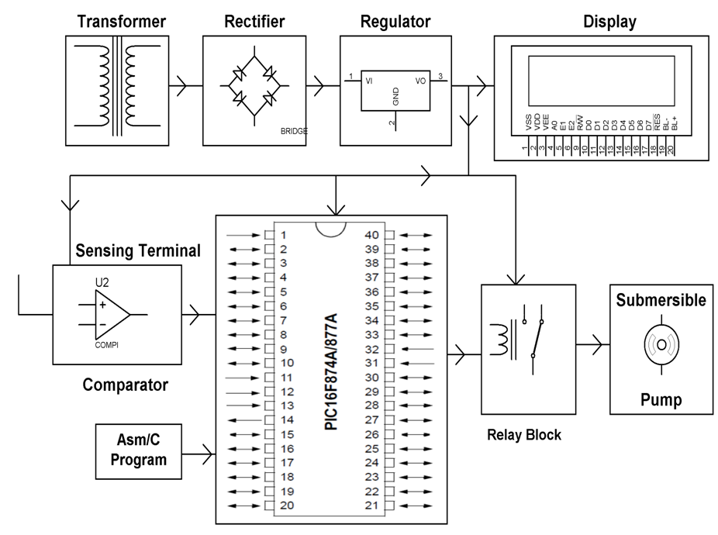
HARDWARE REQUIREMENTS:
PIC series Microcontroller, Op amp, LCD, Relay, Water Pump, Voltage Regulator, Diodes, Capacitors, Resistors, LED, Crystal, Transistor.
SOFTWARE REQUIREMENTS:
HI-TECH PICC Tool suite
Languages: Embedded C or Assembly

